Real time gain tuning and inertia estimation

Owen Lu

Electroimpact Inc.

owenl@electroimpact.com

*Abstract*—This brief document describes the theoretical basis for inertia estimation from radius measurements. The inertia measurement is important for both high and low level controllers, since proportional gains can be increased to speed up the response while simultaneously operating within current limits of the motor.

# Introduction

The main problem is to generate rules to set proportional gain $K_{p}$ based on radius measurements in real time. As the radius of the spool decreases, the open loop gain is effectively lowered, since the radius scales angular velocity for surface speed, thereby reducing the bandwidth of the closed loop system. However, as the radius decreases the inertia of the system also decreases, allowing the proportional gain to be increased to compensate the reduction in performance. We thus, attempt to develop a simple computationally inexpensive rule to ensure consistent performance across any spool diameter.

# Inertia estimation

Previously weighing carbon spools and creating solid models with similar geometry and uniform density was used to estimate the inertia of the spool which is the main inertial element in the system. Interpolation methods were then used to estimate the inertia for any radius that lies within the range of modelled values.

Another simple method is to use a hollow cylinder geometry with uniform density to approximate the inertia.

|  |  |  |
| --- | --- | --- |
|  | $$I_{cyl}=\frac{1}{2}MR^{2}$$ | (1) |

Assuming the carbon portion is uniform density and takes on the form of a hollow cylinder, the carbon inertia can then be approximated with the following method.

|  |  |  |
| --- | --- | --- |
|  | $$I_{cyl}=\frac{1}{2}MR^{2}$$ | (2) |
|  | $$I_{carbon}=\frac{1}{2}ρπr^{4}-\frac{1}{2}ρπr_{0}^{4}$$ | (3) |

The spindle, cardboard roll and other inertia elements are then lumped as a single constant $I_{0}$. Since the second term in the carbon fiber inertia is constant this will also be lumped into $I_{0}$.

|  |  |  |
| --- | --- | --- |
|  | $$I_{effective}(r)=I_{0}+\frac{1}{2}ρπr^{4}$$ | (4) |

The quartic relationship with radius in (4) means that the inertia of the system will decrease rapidly as material is payed out. Notably, the plastic backing wrapping around the take up is neglected for simplicity.

# Inertia calculation comparison

Using data provided by Kyle Jeffries, a curve fit was performed on the inertia approximations. The fit agrees with the current approximation method well and therefore will be used in the controller implementation.

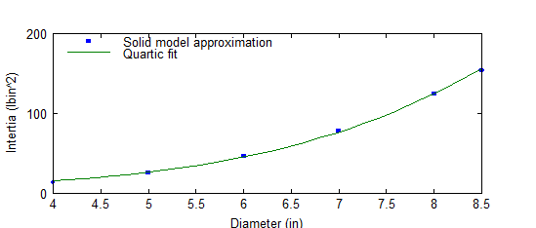

# Proportional gain re-tuning

In order to maintain the same overall disturbance rejection a simple condition is to be maintained.

|  |  |  |
| --- | --- | --- |
|  | $$K_{p}r_{s}=C_{0}$$ | (5) |

Where $C_{0}$ is some constant

Therefore, suppose that initially the gain is set to its maximum when the inertia of the spool is largest using (6).

|  |  |  |
| --- | --- | --- |
|  | $$K_{p}=\frac{2T_{m}}{v_{o}I_{e}}$$ | (6) |

Then, $C_{0}$ can be calculated and an explicit formula used for $K_{p}$ can be obtained. This ensures that the closed loop performance is the same throughout all radii. Thus, the update equation in the control loop is given in (7).

|  |  |  |
| --- | --- | --- |
|  | $$K_{p}=C_{0}/r_{s}$$ | (7) |